**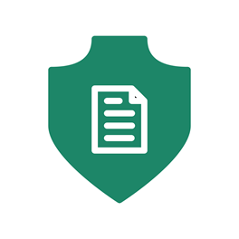**

**LocAdoc**

**User Manual**

**Version 0.1**

**Prepared by: Abhi Jay Krishnan**

**Kim Hyeocheol**

**Rivaldo Erawan**

**Durrah Afshan**

Table of Contents

[1. Introduction 1](#_Toc498782843)

[2. Requirements 1](#_Toc498782844)

[3. Login 1](#_Toc498782845)

[4. Signup 3](#_Toc498782846)

[5. Forgot password (Password Recovery) 5](#_Toc498782847)

[6. Home Screen 6](#_Toc498782848)

[6.1 Home screen (searching area) 7](#_Toc498782849)

[6.2 Home screen (file explorer) 8](#_Toc498782850)

[6.3 Home screen (file operations) 9](#_Toc498782851)

[6.4 PDF viewer 10](#_Toc498782852)

[6.5 Main Menu (Navigation Menu) 11](#_Toc498782853)

[6.6 Add Area 12](#_Toc498782854)

[6.7 Area Operation 13](#_Toc498782855)

[6.8 Add Document (Import Documents) 14](#_Toc498782856)

[7. Settings 16](#_Toc498782857)

[7.1 Change User Name 17](#_Toc498782858)

[7.2 Change password 18](#_Toc498782859)

[7.3 Download Backup Files 19](#_Toc498782860)

[8. About 20](#_Toc498782861)

[9. Delete Account 21](#_Toc498782862)

# Introduction

The objective of this document to allow reader to gain an understanding of the functionalities of LocAdoc application and how to make a proper usage of these features. This document is divided based on the seven main screens that the reader will come across while using the application, they are: -

* Login
* Signup
* Password Recovery
* Home page
* Settings
* About
* Delete Account

# Requirements

|  |  |
| --- | --- |
| Recommended system requirements | |
| Phone Connectivity | GPS and Network connectivity (A-GPS, GLONASS and Wi-Fi 802.11 b/g/n) |
| Operating system | Android 5.1 (lollipop) and above |
| RAM | 1GB |

# Login

|  |  |
| --- | --- |
| C:\Users\user\Downloads\Screenshot_20171116-150306.png | C:\Users\user\Downloads\Screenshot_20171116-150236.png |

This is a login screen which will give you the option to login, signup, and forgot password. There are two appearances, the left screen is shown when there is no account in the device and the right one is shown if you has successfully logged in to the device previously.

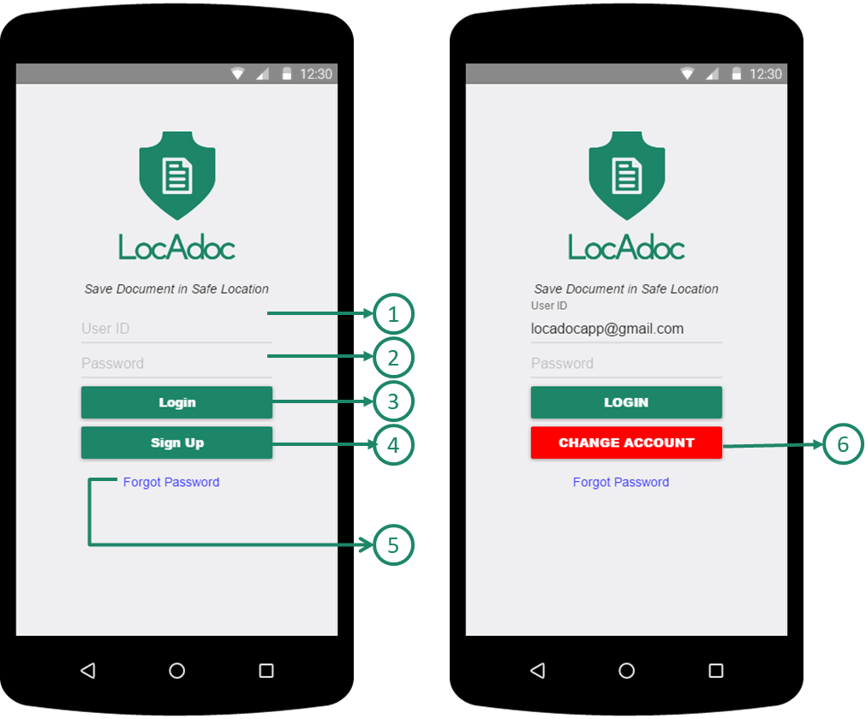

1. **Email Account**: you need to input account’s email
2. **Password**: you need to input account’s password
3. **Login Button**: Login into account with email and password
4. **Sign Up Button**: Go to Sign up Pages to sign up new account **Reference 3.2 Signup**
5. **Forgot Password links**: go to Forgot Password pages. Before access to Forgot Password, you need to write down the account’s email in ①
6. **Change Account button**: Make Empty input in ① fields and allow you to login as another new account

# Signup

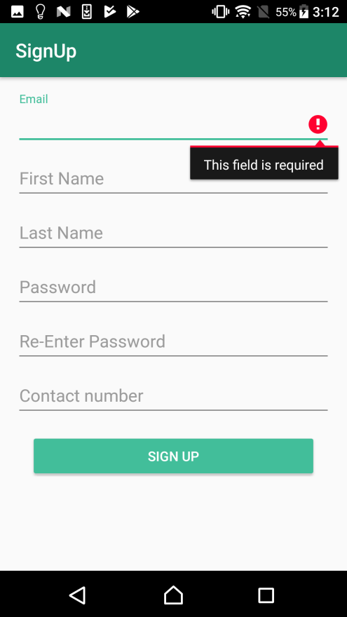 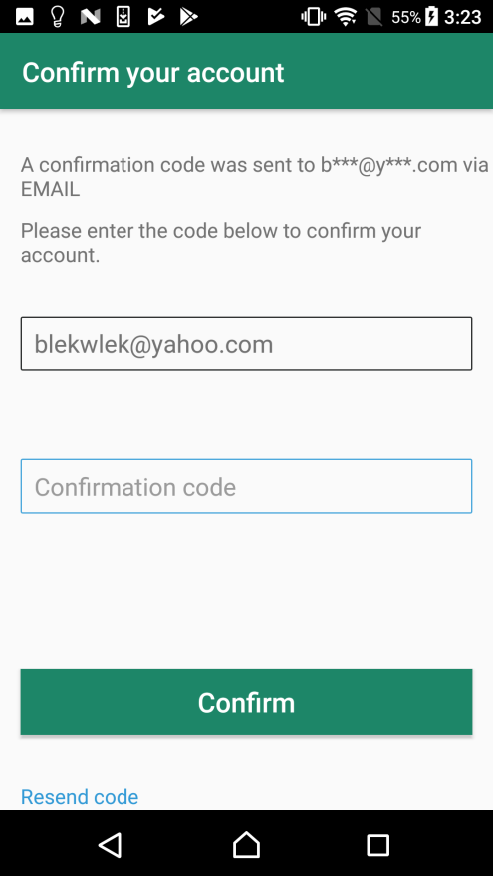

This is the signup form where you can fill the above information and the system will sign up your account for the services.

**Signup – Signup Form process**

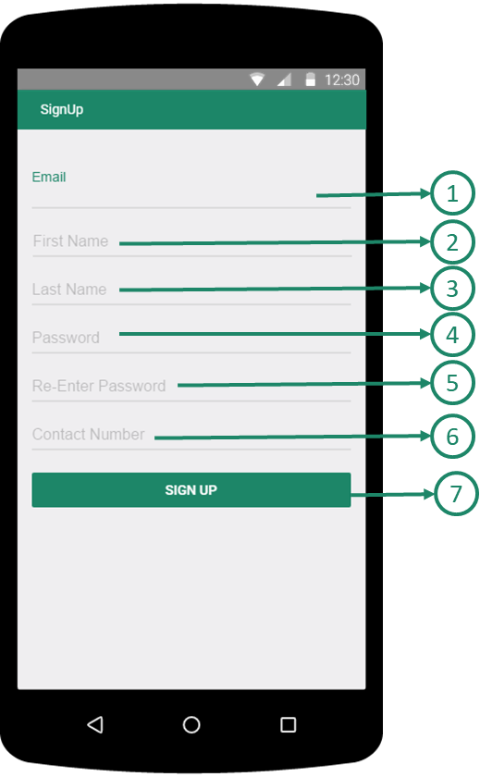 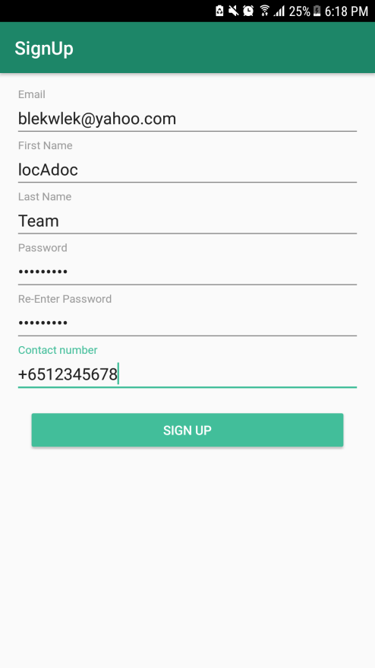

**First Step in Signup**

1. **Email:** You need to input Email Address for Account
2. **First name:** You need to input your first Name
3. **Last name:** You need to input your Last Name
4. **Password**: You need to input your Password, which requires some conditions
   1. The Password should contains both lower case and upper case letters
   2. The Password should contains at least one integer value
   3. The Password length should be between 8 and 12 character
5. **Re-enter password:** You need to input same character as Password
6. **Contact number**: You need to input your contact number.

Input format should be: (Country Code)(Contact Number)

For Example IF your Country is Singapore and Contact Number is 87654321

THEN +6587654321

1. **Signup submission button**: Submission button moving to next verification step in Signup. IF there were wrong format between ① and ⑥, THEN the app will show error message in the wrong field.

**Signup - Verification process in Signup**

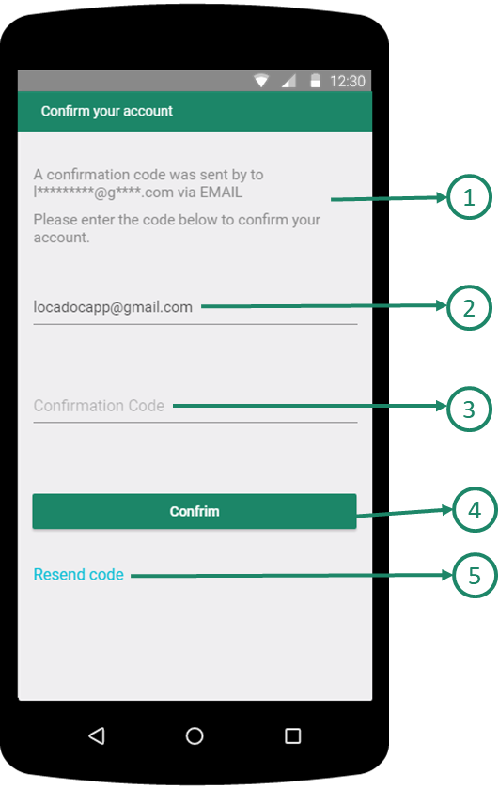 

1. **Application message**: The Application show message that verification code is sent to your email that you has written in signup form.
2. **Email**: Email address that you inputs in Signup Form. You cannot change the email address in this step.
3. **Confirmation code**: You need to input Confirmation Code that you receive via Email
4. **Confirmation submission button**: Submission button with verification code.

IF correct verification code, THEN the app will show success message and do auto login.

IF incorrect verification code, THEN the app will show fail message.

1. **Resend code**: IF you click this text, then the app will email another verification code into your email.

# Forgot password (Password Recovery)

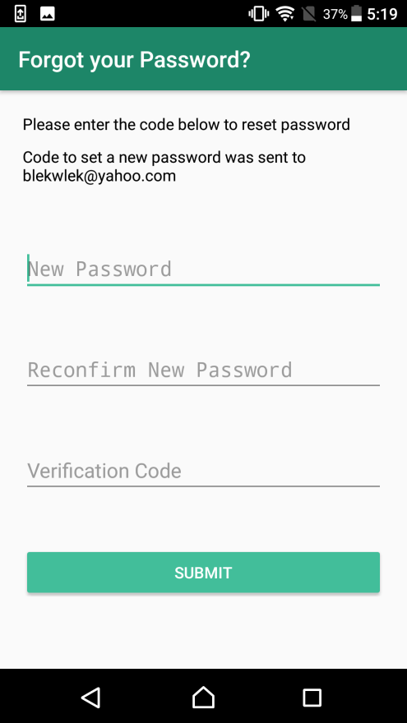

You will fill up the password reset form and on clicking next, a verification code will be sent to the email or phone. In the second screen, you need to enter the verification code.

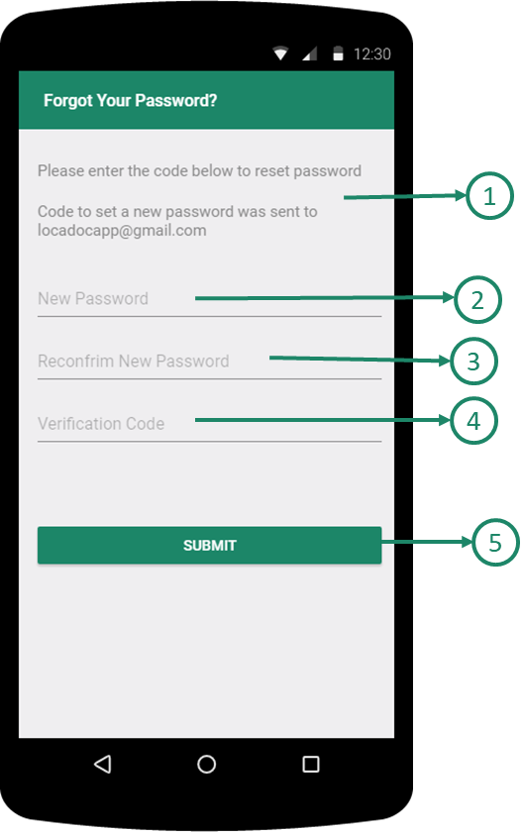 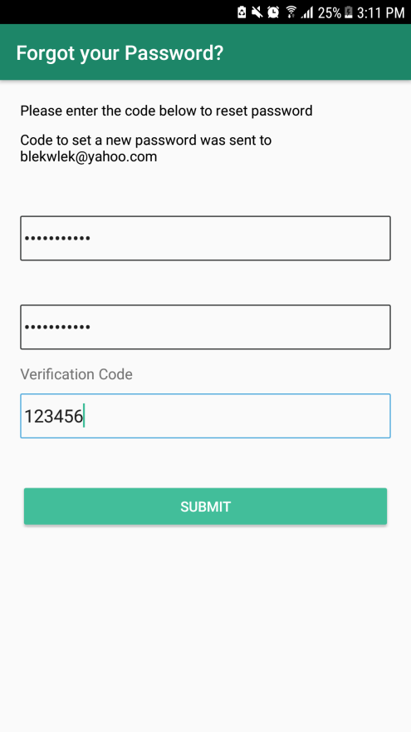

1. **Application Message**: The Application show message that verification code is sent to your email
2. **New Password**:You need to input New Password, which requires some conditions, to access account
   1. The new password should contains both lower case and upper case letter
   2. The new password should contains at least one integer value
   3. The new password length should be between 8 and 12 character
3. **Reconfirm New Password**: You need to input same character as new password
4. **Verification Code**: You need to input verification code that you receive via Email
5. **Submission Button**: Submission button with verification code and New Password for Account. **IF** correct verification code, **THEN** the app will show success message and do auto-login with new Password. **IF** incorrect verification code, **THEN** the app will show fail message.

# Home Screen

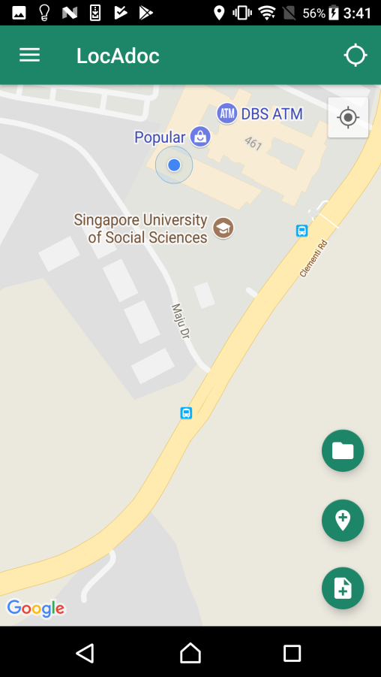

After logging in successfully, you will enter this screen where you get to see a map with your current location and the areas near you. The top bar has a menu icon on the left and a search bar. You may click on the blue dot that represents the area to open up all the files in that location. The plus symbol below leads to adding a new document to the current location.

|  |  |
| --- | --- |
|  | 1. **Navigation Menu Button:** Open the Homepage Navigation Menu 2. **Search Area Button**: Change Toolbar to Search bar to find out Area. Reference ***3.5 Home Screen (Searching Area)*** 3. **Area Marker**: Area Marker or Area’s middle point 4. **Middle point of Area in Area Marker** 5. **Current Location:** This marker shows your current location. 6. **File Explorer Button**: Open File Explorer to view Documents.   Reference ***3.6 Home Screen (browser file)***   1. **Add Area Button**: Open new Screen below to the homepage to add New Area **Reference 3.10 Add Area** 2. **Add Documents Button**: Open new Screen below to the homepage to add documents in either new area or existed area **Reference 3.12 Add Documents(Import Documents)** |

## **Home screen (searching area**)

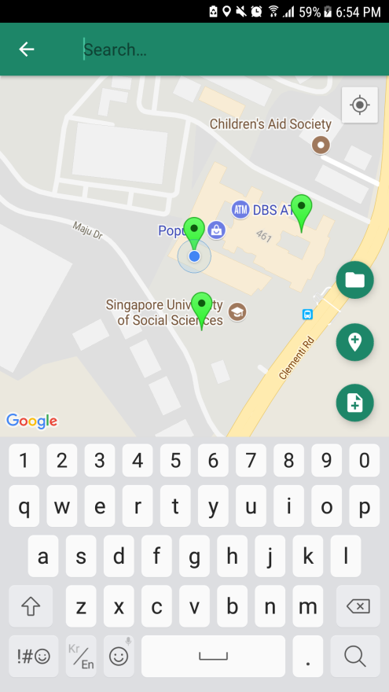 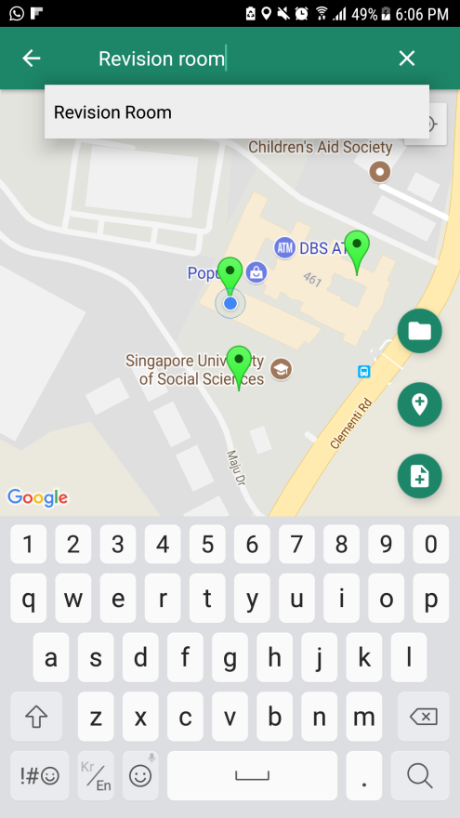

You can search all the area from the search bar but can only access the files under that area if you are in that location.

|  |  |
| --- | --- |
|  | 1. **Go Back Button**: Go Back to Homepage screen 2. **Search Bar**: You should type the name of area to find 3. **Clean Button**: You can clean the input in Area search bar 4. **Result List in Search**: The app show the Result of Area list depends on the your input in Search Bar |

## **Home screen (file explorer**)

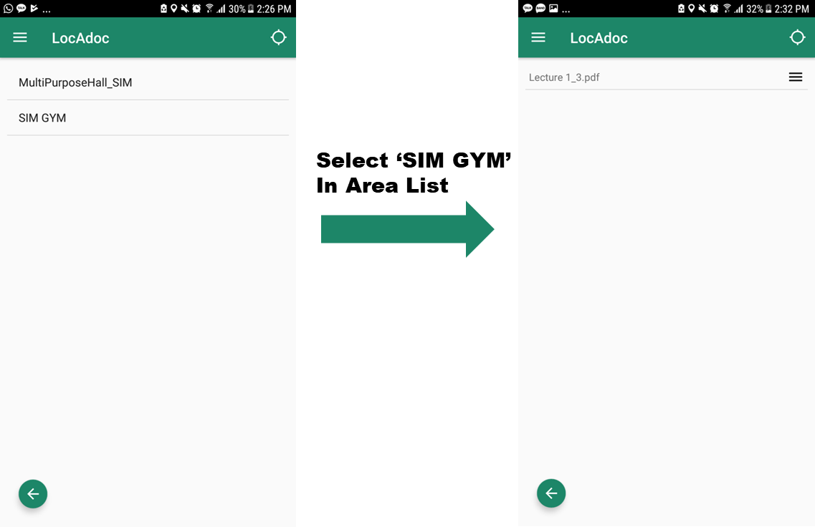

The app will list out all the files that is available in the current area. This screen can be approached by tapping the location pointer on the home screen map.

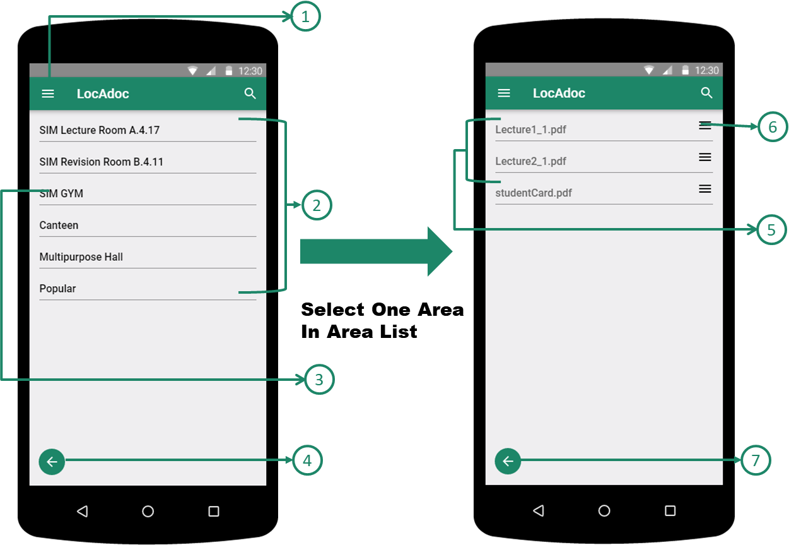

1. **Main Menu (Navigation Menu) Button**: You can open the Homepage Navigation Menu
2. **Area List**: Available Area List depends on the current Location
3. **One Area in Area List**: Area menu in Area Lists to view document lists.
4. **Go Back Button in Area List**: Go back to Homepage
5. **Document List in specific Area**: Available Documents list depends on the selected area.

Clicking any of these will open the files

1. **Document/File Operation Button**: Open the File Operation Dialog
2. **Go Back Button in Document List**: Go back to Area list from document list screen

## Home screen (file operations)

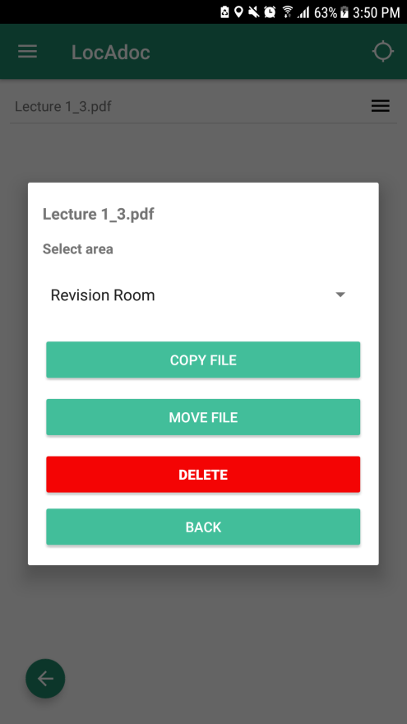

On clicking the 3 lines, a menu will drop down asking if you wish to copy, move, or delete the file

|  |  |
| --- | --- |
|  | 1. **Selected File Name** 2. **Other Areas Name List**: Destination Area to process File Operation 3. **Copy Button**: Copy the selected file into Destination Area depend on the selection in ② 4. **Move File Button**: Move the selected file into Destination Area depend on the selection in ② 5. **Delete File Button**: Delete the Selected file in the area 6. **Go Back Button**: Close the File operation menu |

## PDF viewer

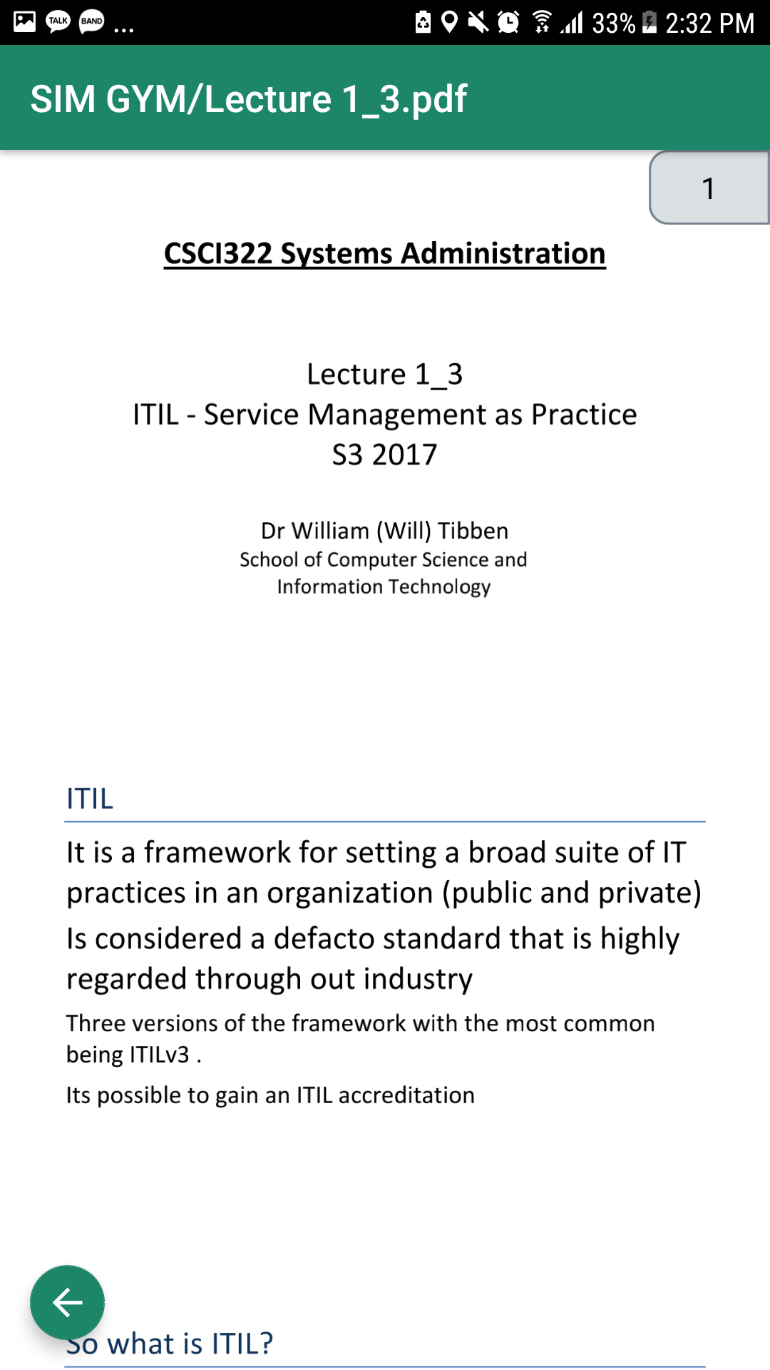

On clicking an item in the file list, the application renders the PDF file and loads up on the screen.

|  |  |
| --- | --- |
|  | 1. **Go Back Button in PDF Viewer:** Go back to Documents list Menu in specific Area 2. **Page Scroll Bar:** Scroll bar showing current pages 3. **PDF Viewer Screen**: show the page’s contents |

## Main Menu (Navigation Menu)

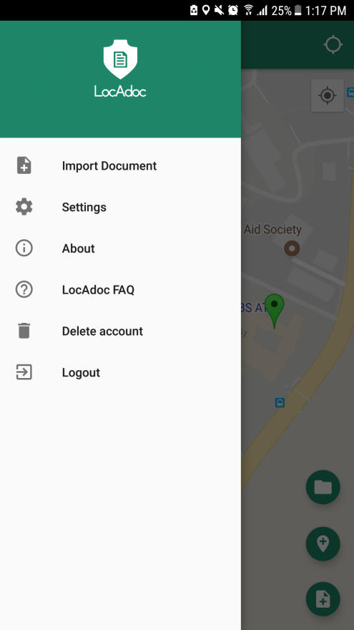

Main menu loads up when you click the icon on the main activity. It has options to add a new document, settings, about, a FAQ link and a logout option.

|  |  |
| --- | --- |
|  | 1. **Import Document Menu**: Open new features below the homepage screen to import the files into area **Reference 3.12 Add Documents(Import Documents)** 2. **Settings Menu**: Go to Setting Menu **Reference** **3.13 Settings** 3. **About Menu**: Show the introduction about LocAdoc **Reference 3.17 About** 4. **LocAdoc FAQ menu**: Open LocAdoc FAQ as web pages 5. **Delete Account menu**: Delete current account 6. **Logout Menu**: Logout from current session |

## Add Area

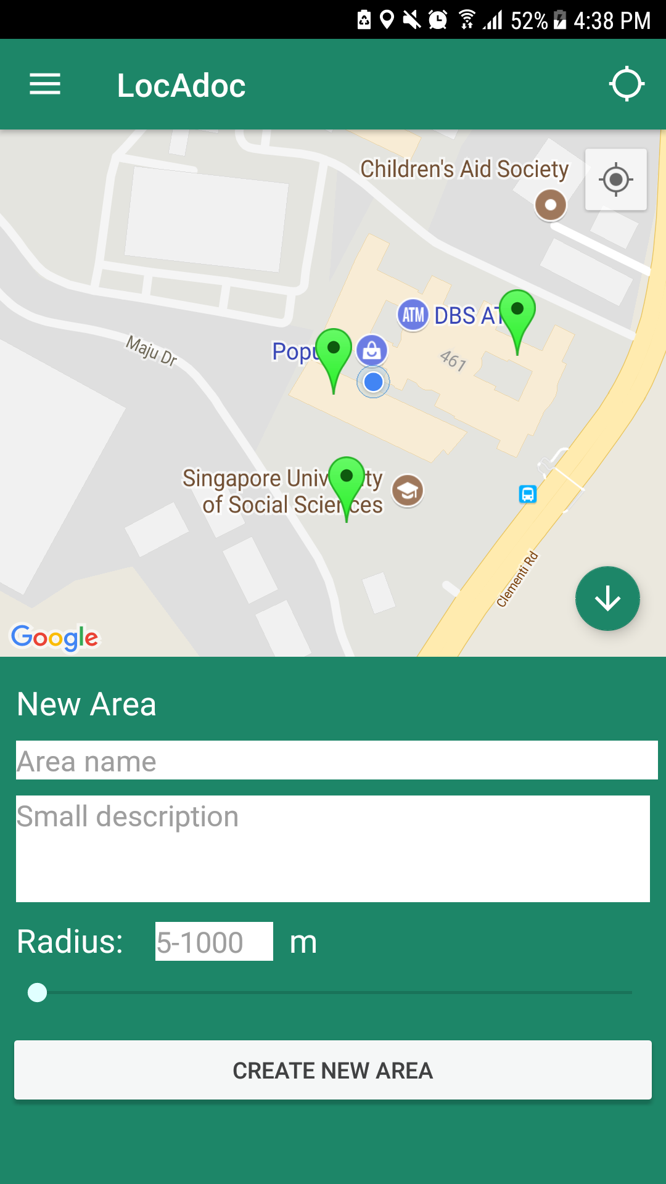

On clicking the Add Area Button, a form to add area will appear from the bottom of the screen and all the buttons will be replaced with Hide Button

|  |  |
| --- | --- |
|  | 1. **Hide Button:** Hide add area form and show the home screen back in full screen 2. **Area Name:** New area name (cannot be empty and must be at least 2 characters) 3. **Area Description:** New area description 4. **Radius Text:** Radius of the new area, editable with keyboard upon clicking the box. Radius value must be between 5 to 1000 meters. 5. **Radius Slider:** Slider to change the radius. 6. **Submit Button:** Create new area |

## Area Operation

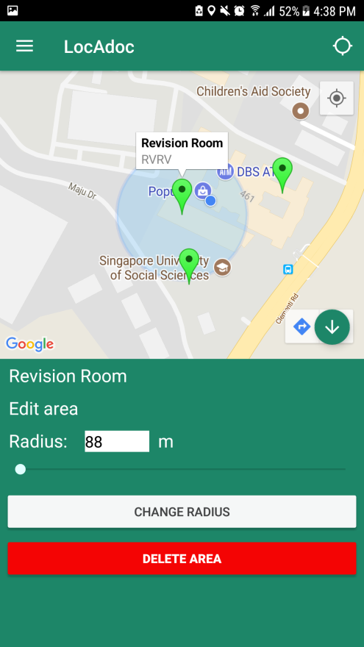

On clicking the marker on the map, if you are within that area’s radius then a form to edit area’s radius or delete the area will appear from the bottom of the screen and all the buttons will be replaced with Hide Button

|  |  |
| --- | --- |
|  | 1. **Hide Button:** Hide add area form and show the home screen back in full screen 2. **Radius Text:** Radius of the new area, editable with keyboard upon clicking the box. Radius value must be between 5 to 1000 meters. 3. **Radius Slider:** Slider to change the radius. 4. **Change Radius Button:** Change the radius of the selected area to the radius inside radius text. 5. **Delete Area Button:** Delete the selected area. If there is still a file inside the area, then you need to delete all the files first before being able to delete it. |

## Add Document (Import Documents)

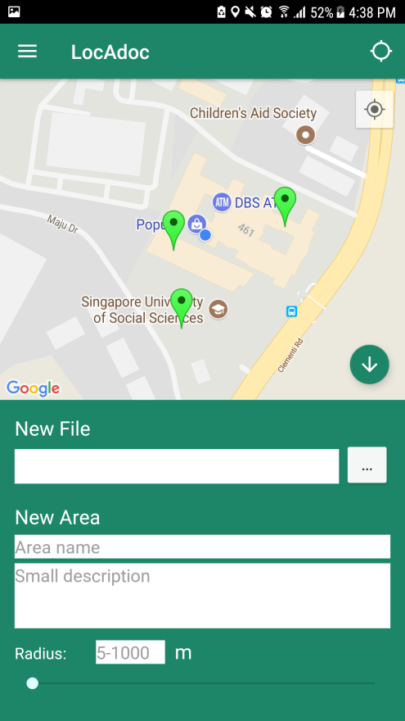 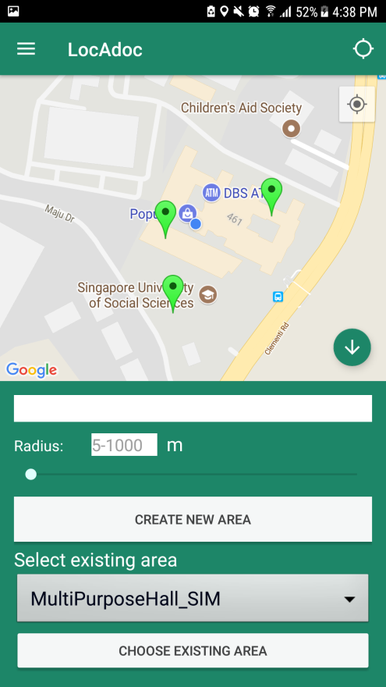

On clicking the add document button, a form to add area will appear from the bottom of the screen and all the buttons will be replaced with Hide Button

|  |  |
| --- | --- |
|  | 1. **Import Files button:** Open a new activity to select a pdf file in the device. Upon successful select, the name of the file will be displayed on the box in the right of the button. 2. **Area Name:** New area name (cannot be empty and must be at least 2 characters) 3. **Area Description:** New area description 4. **Change Radius:** Radius of the new area, editable with keyboard upon clicking the box. Radius value must be between 5 to 1000 meters **OR** Slider to change the radius. 5. **Create New Area Button**: Create New Area and save the selected file into the new area 6. **Existed Area List**: Show the existed areas list. You can choose one of the existed areas. 7. **Existing Area Selection Button**: save the selected file into the existed area |

# Settings

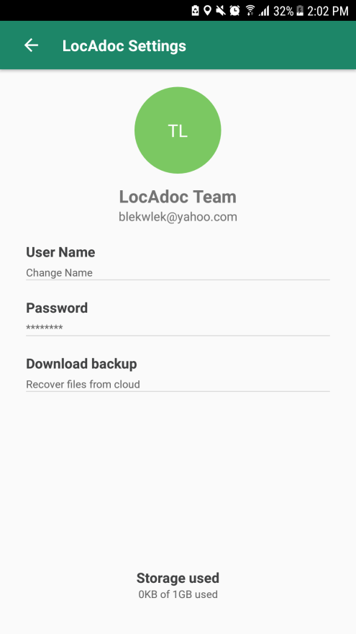

On this page, you get to edit your name, phone number, and see the total size used. You may choose to download all your secured folder in AWS S3 by clicking on download backup. On clicking password will open a new activity to change password.

|  |  |
| --- | --- |
|  | 1. **Go Back Menu in Settings**: Go back to Main Home Page 2. **Initial Name:** Show the your Name initial Name depends on the your first and last name 3. **Current Name:** Show your first and last name and If you click this text, then it will open dialog for changing your name **Reference 3.11 Change Password** 4. **Current Email:** Show your email account address 5. **Changing Name Menu:** Open dialog for changing your name 6. **Changing Password Menu:** Open new screen for changing your current password **Reference 3.11 Change Password** 7. **Download Backup Menu**: Download the backup files from cloud service to current devices 8. **Current File Usage:** show your file usage |

## Change User Name

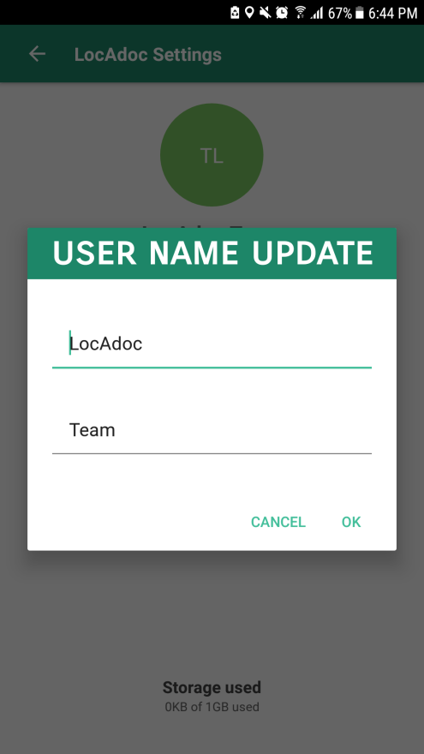

You can change your profile name and initial name by filling up the above dialog form and clicking OK button.

|  |  |
| --- | --- |
|  | 1. **First Name Field:** it will show your current first name and you can modify it 2. **Last Name Field:** it will show your current last name and you can modify it 3. **Cancel Button:** close the changing name dialog 4. **OK Button:** update your name |

## Change password

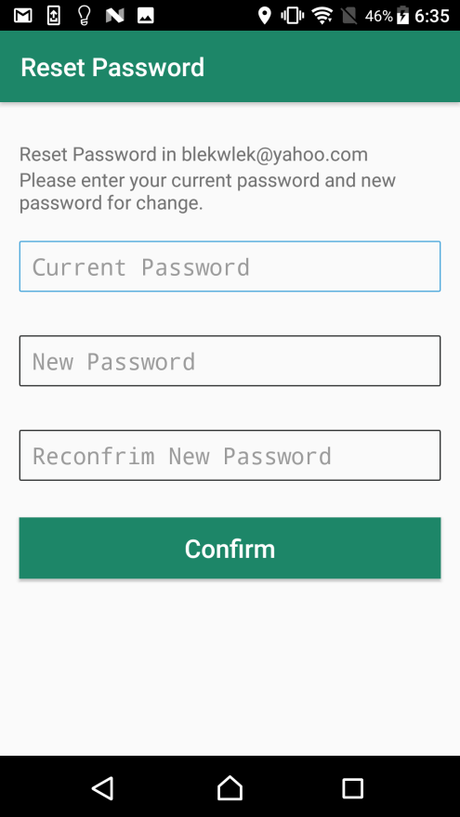

You can change password by filling up the above form and clicking confirm on the top.

|  |  |
| --- | --- |
|  | 1. **Application message**: The Application show message that verification code is sent to your email 2. **Current Password**: You need to input current Password in your account 3. **New Password**: You need to input New Password for next login session    1. The password should contains both lower case and upper case letters    2. The password should contains at least one integer value    3. The password length should be between 8 and 12 character 4. **Confirmation New Password**: You need to input same values as New Password 5. **Confirmation Button**: Submission button with current Password and New Password for Account. **IF** correct current password, **THEN** the app will show success message **ELSE** **THEN** the app will show fail message. |

## Download Backup Files

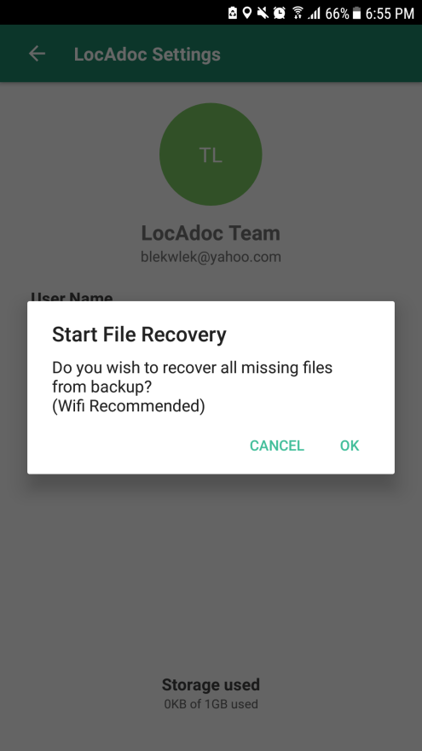

You can download the files from the Backup Cloud server by Clicking Download Backup Files menu and Ok in the dialog. Using WI-FI is recommended to download all backup files, since the total size can be huge.

|  |  |
| --- | --- |
|  | 1. **OK Button**: Download the files from Cloud Backup Server 2. **Cancel Button**: Cancel and Close the current dialog |

# About

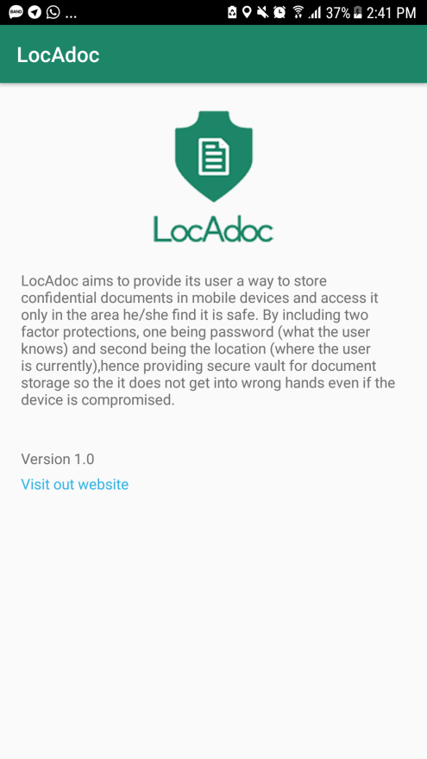

This activity can be reached from main menu and it describes the version of the application and credits.

|  |  |
| --- | --- |
|  | 1. **Visit website Link**: Open LocAdoc website 2. **Introduction in About Us** |

# Delete Account

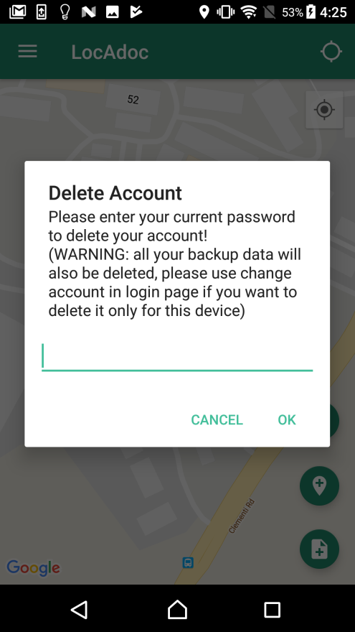

|  |  |
| --- | --- |
|  | 1. **Delete Account Message:** App will show the message about delete account 2. **Password Field:** you need to input current password to delete account 3. **OK Button:** **IF** you input correct password, **THEN** the app will delete the account with Backup data **ELSE THEN** The app will show error message about wrong password 4. **Cancel Button:** cancel the current progress and close the dialog |